**PROJECT DONE BY ZHIJIAN LIU AND ANGELA ERDIAW-KWASIE**

**DATA SCIENCE ANALYSIS OF HI-B VISA APPLICATION IN THE UNITED STATES OF AMERICA.**

**Abstract**

The H-1B is an employment-based, non-immigrant visa category for temporary foreign workers in the United States. Every year, the US immigration department receives over 200,000 petitions and selects 85,000 applications through a random process. The application data is available for public access to perform in-depth longitudinal research and analysis. This data provides key insights into the prevailing wages for job titles being sponsored by US employers under H1-B visa category. In particular, we utilize the 2011-2016 H-1B petition disclosure data to analyze the employers with the most applications, wage distribution and data science related job positions.

**H-1B Visa Data Introduction**

The H-1B is an employment-based, non-immigrant visa category for temporary foreign workers in the United States. For a foreign national to apply for H1-B visa, an US employer must offer a job and petition for H-1B visa with the US immigration department. This is the most common visa status applied for and held by international students once they complete college/ higher education (Masters, PhD) and work in a full-time position.

**Data Wrangling**

In this section, we discuss a few key data transformations performed on the raw dataset before data analysis could be performed. The exhaustive code for the data transformation can be found in the github link attached as well the overall codes used for this project.

**Data Set Description**

The dataset originally had 10 variables with 3002458 observations and we added 25 more variables that we needed in our analysis to make our computation easier.. The extra variables included :

|  |
| --- |
| apply_city:total applications by city  applyrank_city_us:rank of applications  applyrank_city_state  apply_employer_us  applyrank_employer_us "applyrank_employer_state"  [22] "apply_employer_state" "apply_employer_city" "applyrank_employer_city"  [25] "wage_state" "wagerank_state" "wage_city"  [28] "wagerank_city_us" "wagerank_city_state" "wage_employer_us"  [31] "wagerank_employer_us" "wage_employer_state" "wagerank_employer_state"  [34] "wage_employer_city" "wagerank_employer_city" |
|  |
|  |

**DATA TRANSFORMATION**

(1) Format correction of worksites

We expected the format of worksites follow the rule “CITY, STATE”. There are mainly three kinds of wrong formatting:

1) locations contain special mark “#”:



These locations have wrong format of their city, which is substituted by some numbers, building names, street names and so on.

2) locations contain digits:



The expected “CITY”s in these locations are also took place by names of buildings, specific location in building, streets and so on.

3) locations only contain “STATE”:

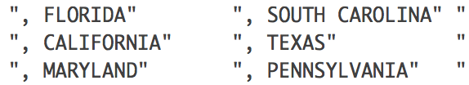

The “CITY”s in these locations are not available, and the strings of WORKSITE is directly start with a comma following with state name.

To detect these wrong formatting of WORKSITE, str_detect was employed:

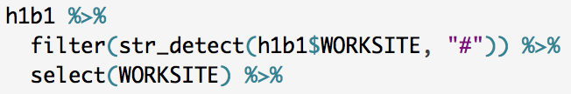

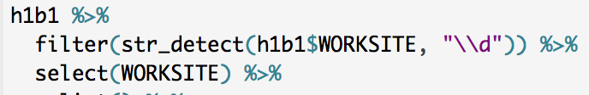

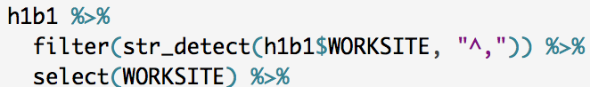

After detecting the wrong formats, according str_replace was used to substituted all the wrong formatting cities with NA. The new form of them became “NA, STATE”.







The “h1b1” data set was the same with “h1b”. It was used to test the methods applied to detect and replace wrong formatting.

(2) Reduction of dataset

Some unreasonable data exists:

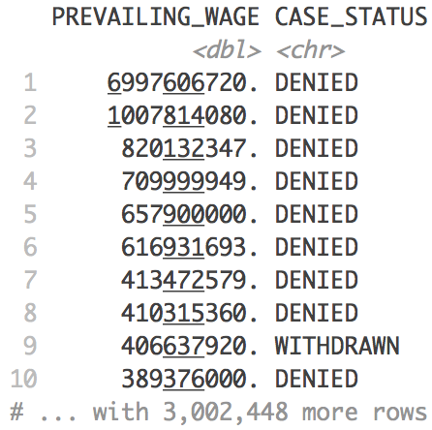

Here we can see the salary of some cases is extremely high. From their “denied” or “withdrawn” status of H1B application, we can regard them as unreasonable cases. The find a line of reasonable salary, I search the “certified” case with highest wage:

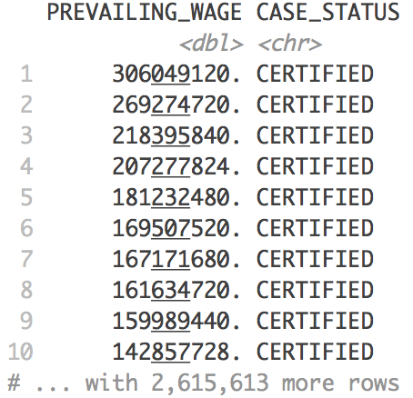

So I got rid of the data which has a higher wage than 306049120$.

(3) Separation of worksite

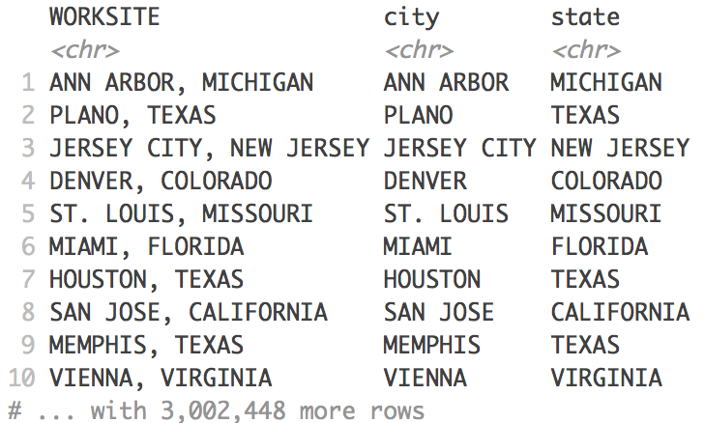

WORKSITE was separated into two variables, “city” and “state”, so that we could do some analysis on states. Meanwhile, WORKSITE itself was retained to make use of ggmap, which requires the format of location as “CITY, STATE”.

(4) Geocode

ggmap package was used to get geographic information, longitude and latitude. Each day, ggmap has a limitation of 2500 queries for geocode. Totally we had 17000 more locations to provide geographic information with. That meant we needed 7 days to get all the geocode.

Before I started, I firstly detected the locations with missing geographic data and them arrange the data by the number of applications of the city.

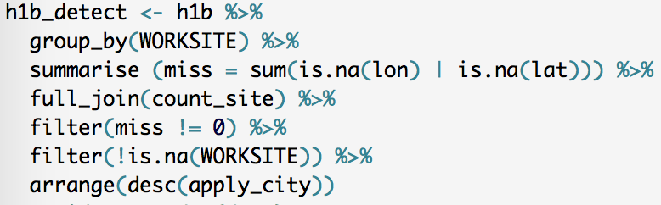

In this case, I could render values to the most number of locations:

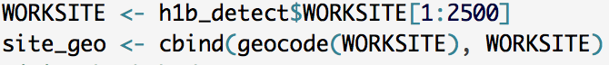

After 40 mins, I got something like this:

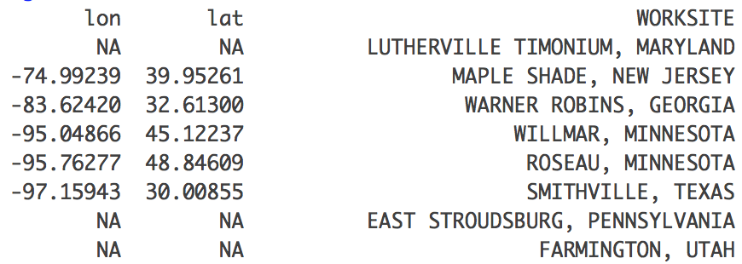

Then I merged the geocode with the dataset of locations will missing geo. data:

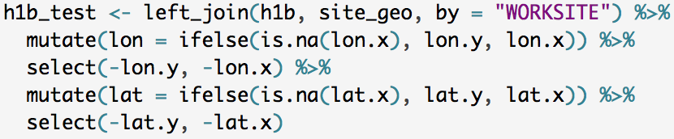

After that, test how many locations were rendered geocode:

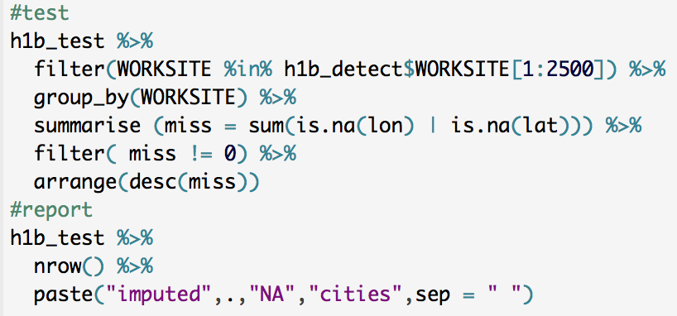

Usually, only half of the queries were success. I think some may be caused by incorrect formatting of WORKSITE. Some may due to the system built between google and R.

After the test, the merged data could replace the metadata and be saved:

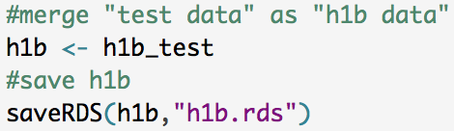

**DATA ANALYSIS**

The questions we will be answering through data include:

1) Which Employers submit the most number of H-1B visa applications?

2) What are the most common Job Titles applied for by the high applicant employers?

3) Distribution of the wages of the top 15 Job titles sponsored by the top employer applicants.

4)Which employer submit the most Data Science Job related applications**?**

5) Which state submit the highest data science related applications ?

6) Distribution of wages of among the top ten Data Science Related Jobs States.

7)Distribution of applications within DC, VA and MD over the years?

8) Highest Data Science related job title h1b visa application state within DC, VA and MD.

9) Among Virginia, DC and Maryland, which state is the highest data science related job title paying state?

**Which Employers submit the most number of H-1B visa applications?**

|  |
| --- |
| Top10 EMPLOYERS  EMPLOYERS NUMBER OF APPLICATIONS  101628 INFOSYS LIMITED 130592  202574 TATA CONSULTANCY SERVICES LIMITED 64726  230799 WIPRO LIMITED 48117  57032 DELOITTE CONSULTING LLP 36742  98190 IBM INDIA PRIVATE LIMITED 34219  3522 ACCENTURE LLP 33447  135595 MICROSOFT CORPORATION 25576  91895 HCL AMERICA, INC. 22678  69986 ERNST & YOUNG U.S. LLP 18232  45941 COGNIZANT TECHNOLOGY SOLUTIONS U.S. CORPORATION 17528 |

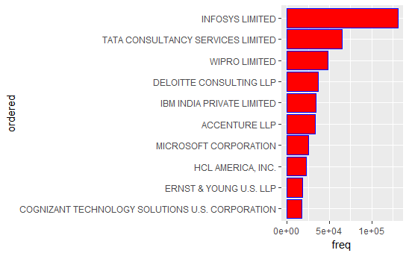

**Distribution of H1-B by top 10 Employers across the years(2011-2016)**

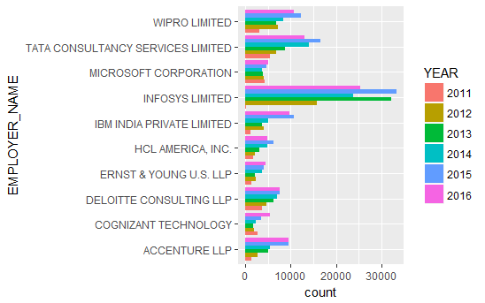

1. Infosys leads the pack by a huge margin with over 30000 applications in 2013 and 2015.
2. The Top 10 list is dominated by the Indian IT companies.(Wipro Limited, Microsoft Corporation, Tata Consultancy Limited, Cognizant Technology and Infosys)
3. In 2016, we observe a slight dip in the number of applications from Infosys, Wipro, Tata Consultancy, IBM India and HCL America. This might be because of increased incorporation of automation in the IT industry. According to an article(link to article will be attached) called the Quartz India, the Indian IT firms have been preparing for reduced number of H-1B visas for nearly a decade through increased focus on automation, cloud computing and artificial intelligence.

**What are the most common Job Titles applied for by the high applicant employers?**

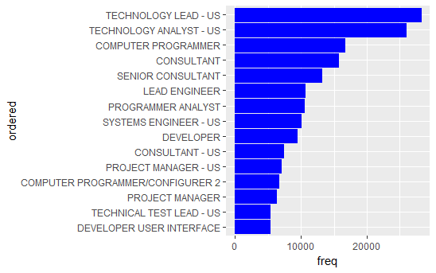**Observations:**

1. Technology related jobs fill up majority of the positions with the top 3 jobs being Technology Lead, Technology Analyst and Computer Programmer.
2. Consultant and Manager related jobs fill up the remaining spots.

**Distribution of the wages of the top 15 Job titles using the box plots**

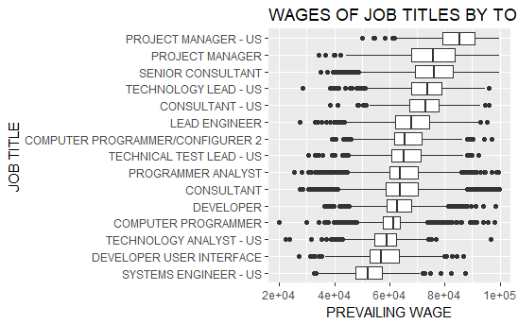

**observations**

Expectedly, the Manager level jobs and Lead Consultant job titles have the highest wages.

2. The Software Engineering jobs including Programmer analyst, Computer Programmer, Computer Systems Engineer have wages close to 60000 USD per annum.

3. Test Analyst and Systems Engineer have the lowest wages with the median slightly above 50000 USD.

**Which employer submit the most Data Science Job related applications? .**

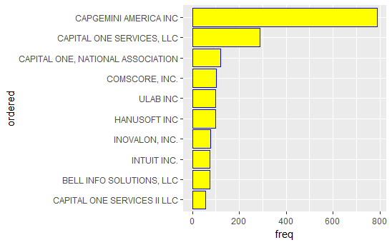

Observation:

1)CAPGEMIN AMERICA INC followed by Capital One Services LLC submit the most Data Science related applications.

2)The top ten companies with the highest overall applications do not submit more applications for Data Science Related Job.

**Which state submit the highest data science related applications .**

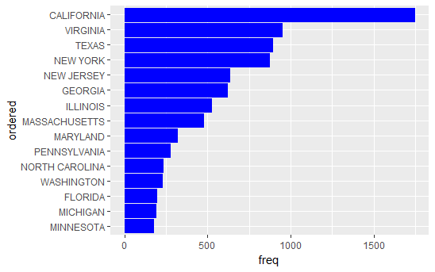

**Observations:**

1. California leads the pack by a huge margin with over 1500 applications.
2. This result is expected as these states are hub of technology innovation with California housing the Silicon Valley, NY housing the Finance and media corporations.

**Distribution of wages of among the top ten Data Science Related Jobs State.**

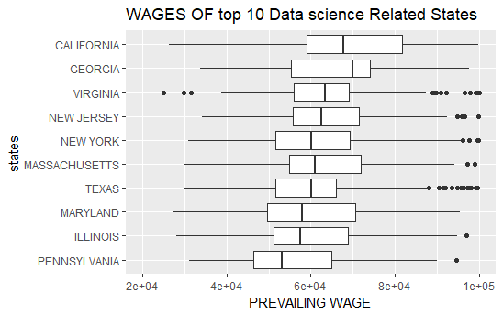

**Observations**

1. California has not only got the most number of jobs but also the highest wages. This might be due to the higher cost of living as I will analyze later.

2. Significant variation in the mean wage across the states.

**Distribution of applications within DC, VA and MD over the years**

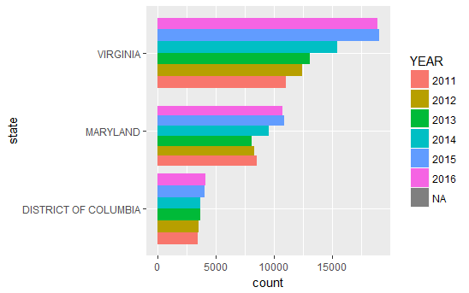

8) Highest Data Science related job title h1b visa application state within DC, VA and MD

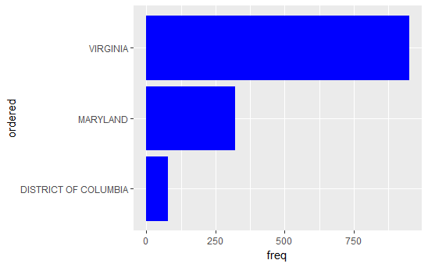

Virginia leads with over 949 applications followed by Maryland with 318 applications and then District of Columbia which has 74 applications.

Among Virginia, DC and Maryland, which state is the highest data science related job title paying state?

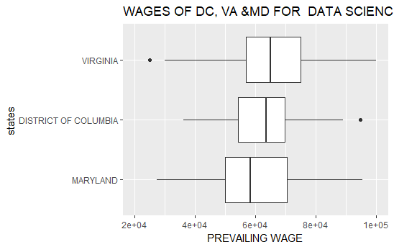

**Conclusion**

To conclude, in this project, we performed exploratory data analysis on the H-1B visa petition disclosure data for the period 2011-201. Also, I found that the Data Scientist position has experiences an exponential growth in terms of H-1B visa applications. Interestingly, the Data Scientist jobs are clustered in a few hostpots with San Francisco region having the highest number. The top ten companies with the highest overall applications do not submit more applications for Data Science Related Job.

**Shiny app**

We expanded this project to build a [Shiny app](https://lobs.shinyapps.io/H1B_map/).

(1) Tools

1) leaflet

Leaflet package was employed to create interactive maps to show the distribution of H1B applications and the wage distribution of H1B employees all over the U.S:

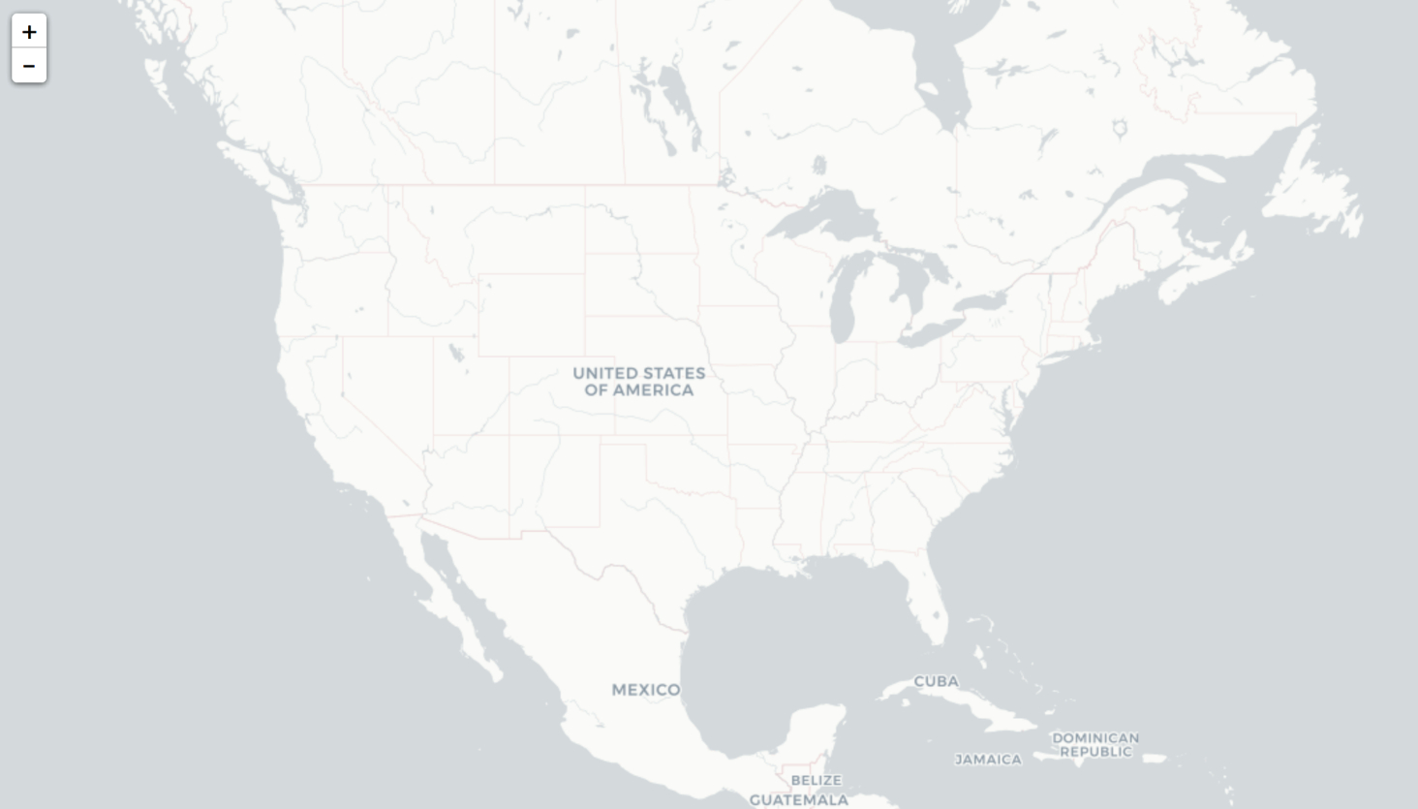

2) Flexdashboard

Flexdashboard package enabled us to flexibly construct widgets and arrange them in an elegant way:

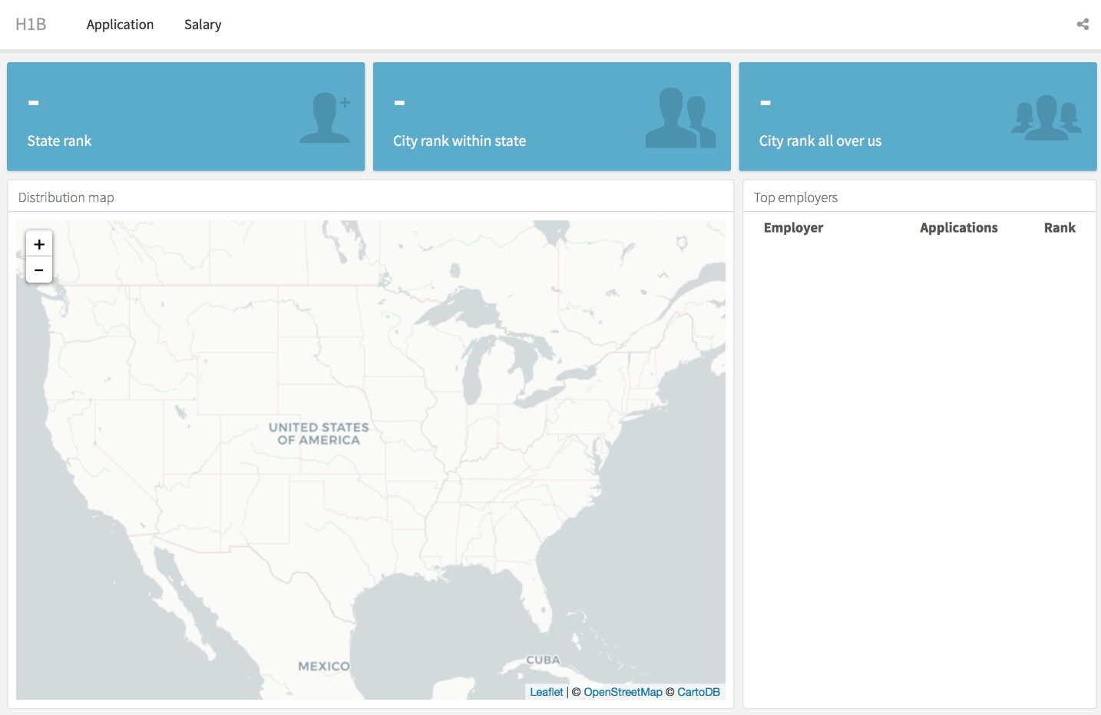

Besides, we don’t need to separately build ui and server anymore. We can possibly integrate input and output all in a chunk. And the tags of inputs and outputs are not necessary, unless you need the corresponding interaction.

This property can be shown in the comparison below:

1) flexdashboard

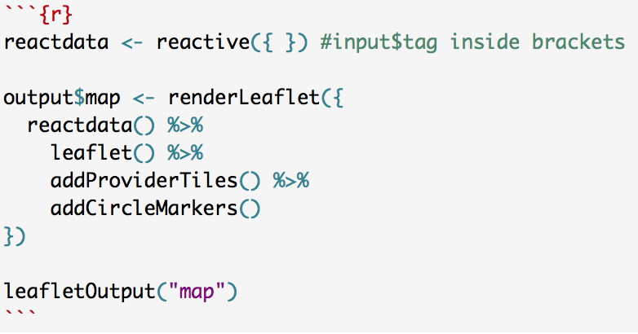

2) traditional way

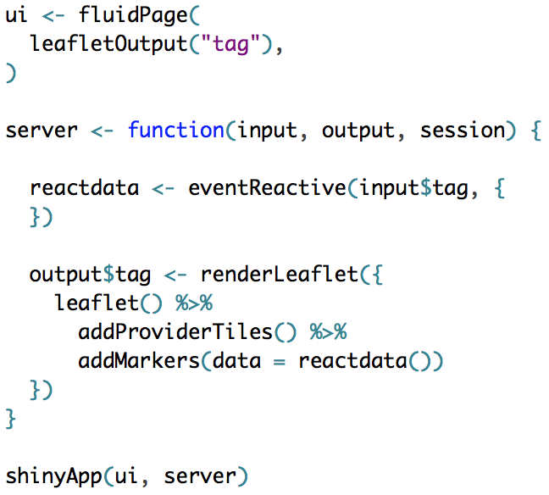

Next, I will make some introduction of the H1B Shiny app.

The Shiny app combine the use of leaflet and flexdashboard. It has two pages. The first page show the distribution of number of applications in different locations all over the U.S. The size of the circles is determine by the number of applications of the city. Three widgets on the top accordingly show the rank by the number of applications. When its rank is high, its color would change from blue to orange. The first widget shows the rank of the state, where the selected city locates, over all the states in the U.S. The second one shows the rank of the selected city within the state. The third one shows the rank of the selected city over all cities in the U.S. On the right side, the table shows the information of top employers in the selected city, including their names, number of applications and the rank within the city. When you click different cities in the map, the widgets will accordingly change. Besides, an information wrapper will pop out to show the name of the city, its state, the total number of its application, and how much proportion it shares over all cities in the U.S.

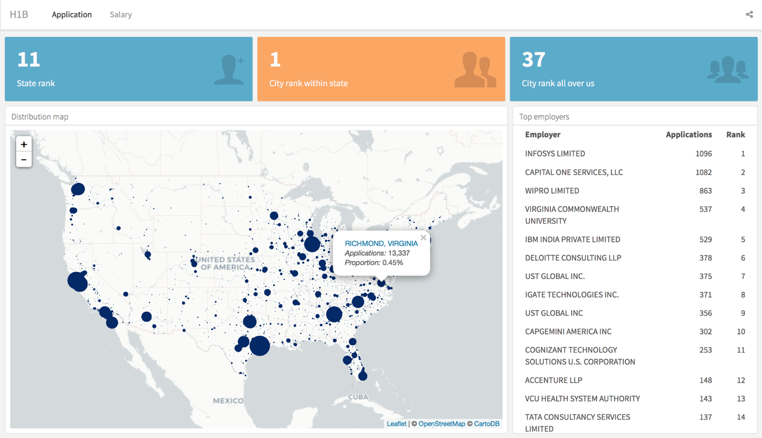

The second page will show something similar about the average wage.

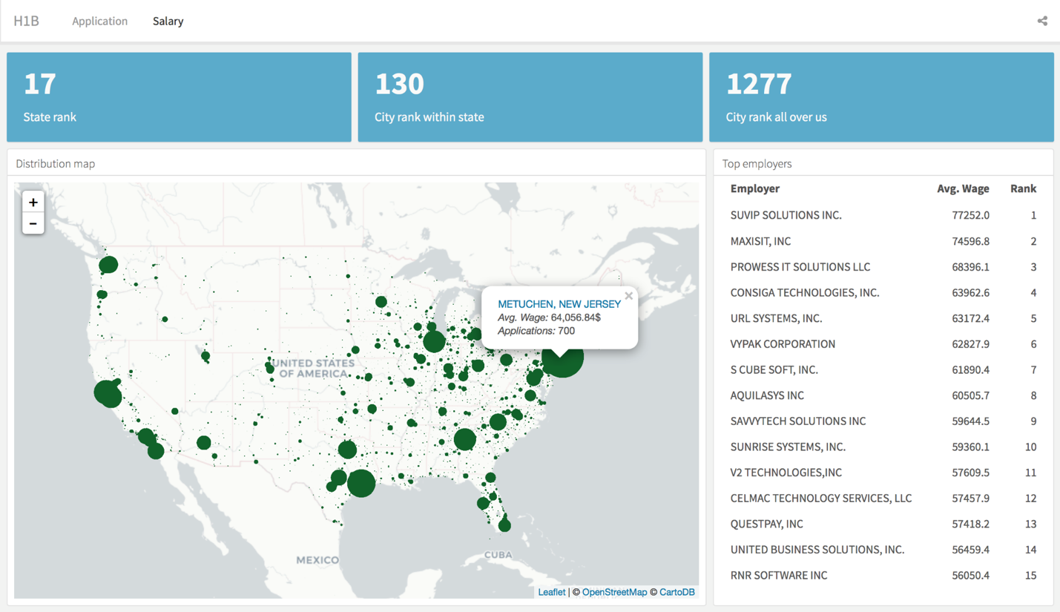

One main problem of this Shiny app is it low performance. It runs very slow. Each time, it will take 20 seconds to load the whole app. When you play with it, it reacts slowly and is sometimes frozen. This may due to the large size of the dataset it uses. I have tried to reduce the size of data as much as possible to 7.3 MB with the format .rds. Also, I reduce the number of packages it loads. However, it still loads slowly. It is the most frustrating thing.

In the future, some interesting stuffs can be added to this app. For instance, a mouse hover action can be employed. When the mouse move over the name of a variable, it will show the description about that variable, so that more explanation about this app could be shown. Moreover, information about changes through the years, jobs and living cost can also be added.